Health Monitoring System

*Submitted in partial fulfilment of the requirements*

*of the degree of*

BACHELOR OF ENGINEERING

*In*

INFORMATION TECHNOLOGY

(A.Y. 2019-2020)

By

Ujwal Agrawal (Roll No.:02)

Rucha Belgali (Roll No.:04)

Kirtan Desai (Roll No.:18)

Under the Guidance of

(Dr. Sangeeta Vhatkar)

Assistant Professor, I.T Department, TCET



**University of Mumbai**



|  |  |  |  |
| --- | --- | --- | --- |
|  |  |  |  |
|  |  | C:\Users\os\AppData\Local\Microsoft\Windows\Clipboard\HistoryData\{F2D32D3E-0996-4F02-B300-A6634DF96AD2}\{9BF2DF18-07CE-4C66-A25A-B7E742930DDF}\ResourceMap\{8F9A71A7-22FC-42EF-A023-6AAC83241602} |  |

**Certificate**

This is to certify that Mr. Ujwal Agrawal, Ms. Rucha belgali, Mr. Kirtan Desai

are bonafide students of Information Technology Department, Thakur College of Engineering and Technology, Mumbai. They have satisfactorily completed the requirements of IP MINI PROJECT as prescribed by the University of Mumbai, while working on “Project Title”.

|  |  |
| --- | --- |
| Signature :------------------------------Name : Mr. Shridhar Kamble  Assistant Professor | Signature :------------------------------  Name : Dr. Rajesh S. Bansode  HOD-IT |
|  | |

|  |
| --- |
| **Internal Examiner: External Examiner:** |
| Signature :--------------------------------- Signature :---------------------------------  Name : Name : |
| Thakur College of Engineering and Technology, Kandivali (East) Mumbai.  Date:  Place: |

**Declaration**

I/we declare that this written submission represents my/our ideas in my/our own words and where others ideas or words have been included; I/we have adequately cited and referenced the original sources. I/we also declare that I/we have adhered to all principles of academic honesty and integrity and have not misrepresented or fabricated or falsified any idea/data/fact/source in my/our submission. I/we understand that any violation of the above will be cause for disciplinary action by the Institute and canal so evoke penal action from the sources which have thus not been properly cited or from whom proper permission has not been taken when needed.

-----------------------------------------

Ujwal Agrawal (2)

-----------------------------------------

Rucha Belgali (4)

-----------------------------------------

Kirtan Agrawal (18)

Date:

**Acknowledgement**

**ACKNOWLEDGEMENT**

The success and final outcome of this project required a lot of guidance and assistance from many people and I am extremely privileged to have completed the project successfully. I would like to thank everyone for their guidance.

We sincerely thank our principal, Dr B.K. Mishra and HOD, Dr Rajesh Bansode for always encouraging us to do our best. We highly indebted to our guide **Dr Sangeeta Vhatkar,** who supported and constantly supervised us throughout the project and helped us in not only completing this project but also provided us with ample amount of knowledge that was really beneficial to us.

We are thankful to and fortunate enough to get constant encouragement, support and guidance from all Teaching staffs of IT Department who helped us in successfully completing our project work. Also, we would like to extend our sincere thanks to all staff in laboratory for their timely support.

We would like to express our gratitude towards our parents for their kind co-operation and encouragement which helped us in completion of this project.

Ujwal Agrawal (02)

Rucha Belgali (04)

Kirtan Desai (18)

**ABSTRACT**

IOT devices is used in many fields which make the user’s daily life more comfortable. Many smart sensors are used to measure and detect different health indicators but it becomes expensive and tedious to have different health monitoring devices. Temperature, humidity and heart rate are the most common and basic health detectors needed for every patient in any health care facility. Hence in this project we have tried to integrate all these health indicators into a single health monitoring station which communicates over Bluetooth to a desired device. This paper discusses about a simple system can be used by friends and families of patients as well as doctors to keep a check on the patients’ health.

|  |  |  |  |
| --- | --- | --- | --- |
|  |  | **List of Figures** | **Page no.** |
|  |  |  |  |
|  | **Fig 3.1** | **Arduino Uno** | **21** |
|  |  |  |  |
|  | **Fig 3.2** | **DHT11 temperature & humidity sensor** | **22** |
|  |  |  |  |
|  | **Fig 3.3** | **LM35 Temperature sensor** | **22** |
|  |  | |  |
|  | **Fig 3.4 Pulse heart rate sensor** | | **23** |
|  |  | |  |
|  | **Fig 3.5 Breadboard and connecting wires** | | **24** |
|  |  |  |  |
|  | **Fig 3.6** | **10k ohm resistor** | **24** |
|  |  |  |  |
|  | **Fig 3.7** | **Gantt Chart** | **25** |
|  |  |  |  |
|  | **Fig 4.1** | **Block Diagram** | **27** |
|  |  |  |  |
|  | **Fig 4.2** | **Final running of project** | **28** |
|  |  |  |  |

**List of tables**

**Page No.**

**2.2.1 Literature Survey Table 16**

**C O N T E N T S**

|  |  |  |  |  |
| --- | --- | --- | --- | --- |
|  | • | Certificate | | *i* |
|  | • | Declaration | | *ii* |
|  | • | Acknowledgments | | *iii* |
|  | • | Abstract | | *iv* |
|  | • | List of Figures | | *v* |
|  | • | List of Tables | | *v* |
|  |  |  | |  |
|  |  |  |  |  |
| **Chapter No.** |  |  | **Topic** | **Pg. No.** |
| **Chapter 1** | **Overview** | |  | 9 |
|  |  | 1.1 | Introduction | 10 |
|  |  | 1.2 | Background | 11 |
|  |  | 1.3 | Importance of the Project | 12 |
|  |  | 1.4 | Motivation | 12 |
|  |  | 1.5 | Scope of the project | 13 |
|  |  | 1.6 | Summary | 13 |
| **Chapter 2** | **Literature Survey & Proposed Work** | | | 14 |
|  |  | 2.1 | Introduction | 15 |
|  |  | 2.2 | Literature Survey Table | 16 |
|  |  | 2.3 | Problem Definition (Phase Wise) | 17 |
|  |  | 2.4 | Features of the project | 18 |
|  |  | 2.5 | Methodology used | 18 |
| **Chapter 3** | **Analysis and Planning** | | | 19 |
|  |  | 3.1 | Introduction | 20 |
|  |  | 3.2 | Feasibility Study | 20 |
|  |  | 3.3 | Project Planning (Resources, Tools used) | 21 |
|  |  | 3.4 | Scheduling | 25 |
|  |  | 3.5 | Understanding | 25 |
| **Chapter 4** | **Design Requirements** | | | 26 |
|  |  | 4.1 | Block Diagram | 27 |
|  |  | 4.2 | GUI Design (Screenshots) | 28 |
| **Chapter 5** | **Results & Discussions** | | | 29 |
|  |  | 5.1 | Actual Results | 30 |
|  |  | 5.2 | Improvements in research gaps | 33 |
| **Chapter 6** | **Conclusion** | |  | 34 |
|  |  | 6.1 | Future Scope | 35 |
|  |  | 6.2 | Conclusion | 35 |

**References 36**

**CHAPTER 1**

**Overview**

**1.1 Introduction**

Today several devices are commercially available for personal health care and activity awareness. A recent health care system should give better health care services to people at any time anywhere in an affordable and patient friendly way. Currently, the health care system going to change from a traditional approach to a modernized patient centered approach. In the traditional way the doctors play the major role. For necessary diagnosis and advising they need to visit the doctor.

Although the main objective of these readers is that patients know their vital signs daily, there is reason to be second on the list of priorities when taken daily shows, and is to be stored consistently results which shed daily tests so they can be the subject of medical studies. Similarly, also the readings that do permanently to patients reports, doctors recommend you also workout routines that allow them to improve the quality of life and overcome such diseases4. The internet of things applied to the care and monitoring of patients is increasingly common in the health sector, seeking to improve the quality of life of people.

Now, Internet of Things (IOT) has become one of the most powerful communication paradigms of the 21st century. In the IOT environment, all objects in our daily life become part of the internet due to their communication and computing capabilities. Heart rate is one of the fundamental physiological limits, essential for monitoring and diagnosis of patients. To keep people effective and healthy, a readily accessible modern health care system is proving to be effective in saving costs, reducing illness and prolonging life. In this paper, an enhanced healthcare monitoring system is described, that is smart phone based and designed to offer wireless approach and social support to participants.

**1.2: Background**

Earlier it was difficult to get the correct readings and it needed help of a health care professional to read the acquired readings. Each health indicator had its own devices which would be expensive for the common man to keep at home. Patient health monitoring is very important on a daily basis in clean, fast and efficient way. The increased use of mobile technologies and smart devices in the area of health has caused great impact on the world. Health experts are increasingly taking advantage of the benefits these technologies bring, thus generating a significant improvement in health care in clinical settings and out of them.

Likewise, countless ordinary users are being served from the advantages of the Mobile Health applications and E-Health (health care supported by ICT) to improve, help and assist their health. Applications that have had a major refuge for these users, so intuitive environment. The Internet of things is increasingly allowing to integrate devices capable of connecting to the Internet and provide information on the state of health of patients and provide information in real time to doctors who assist.

**1.3: Importance of the project**

The requirement of the health monitoring station and is because of the increase in population the need to keep up with latest health trends which is to measure some basic health characteristics often to analyse it and find any anomaly in it if any. Hence, there is great importance of the project in day-to-day life. Importance of Health Monitoring Station are as below:

* Correctly monitor the different health indicators of the patient.
* Will integrate different health monitoring sensors into one device hence making it affordable.
* To make it user friendly for use at home or in the hospital using app connected via Bluetooth.
* Put health monitoring devices in the mainstream market.

**1.4: Motivation**

In rural hospitals, the facilities for health caring area limited. The poor quality of health management enables issues in health care system. Everyone should get the knowledge of own health as easy and early as possible. Also, it should be worth for each. Latest report of The India Spend analysis of data says that the 500,000 doctor’s shortage in India. WHO defines the doctor patient ratio will be 1:1000 which has been failed in India.

In developing countries there is lack of resources and management to reach out the problems of individuals. A common man cannot afford the expensive and daily check-up for his health. For this purpose, various systems which give easy and assured caring unit has been developed.

**1.5: Objectives and scope of the project**

The main objective of the project is monitoring health parameters of patient wirelessly. The parameters include temperature and heart beat rate of the patient. These parameters are continuously monitored and displayed on the doctor’s mobile. This helps the doctor to have the updated information of the patient. The features of the whole system is as follows.

* The system is easy to use and access the parameters.
* The parameters are transmitted to the doctor’s mobile wirelessly
* Input to the system is given by the sensors that are connected to the Arduino.
* Cost effectiveness making it accessible to common public.
* Easy to use.

According to the availability of sensors or development in biomedical trend more parameter can be sensed and monitored which will drastically improve the efficiency of the wireless monitoring system in biomedical field. A graphical LCD can be used to display a graph of rate of change of health parameters over time. The whole health monitoring system which we have framed can be integrated into a small compact unit as small as a cell phone or a wrist watch. This will help the patients to easily carry this device with them wherever they go. In addition, with medical application we can use our system in industrial and agricultural application by using sensors like humidity sensors, fertility check sensors, etc.

**1.6 Summary**

The sensors will record signals in a continuous manner, they are then correlated with the essential physiological parameters and communicated over the wireless network. The resulting data is stored, processed and analysed with the existing health records. Using the available data records and decision support systems, the physician can do a better prognosis so that to suggest early treatment. Even when the doctor is not available, this analysis enables the today’s machines to predict the health issues. Not only prediction, machines can also be able to come out with the medicines from the systematic study of the medicinal databases.

**Chapter 2**

**Literature Survey & Proposed**

**Work**

**2.1 Literature survey**

A literature review surveys scholarly articles, books, dissertations, conference proceedings and other resources which are relevant to a particular issue, area of research, or theory and provides context for a dissertation by identifying past research.

Research tells a story and the existing literature helps us identify where we are in the story currently. It is up to those writing a dissertation to continue that story with new research and new perspectives but they must first be familiar with the story before they can move forward

**2.2 Literature survey table**

|  |  |  |  |  |
| --- | --- | --- | --- | --- |
| **Sr. No** | **Paper Title & Year** | **Author Name** | **Key finding** | **Results** |
| 1 | Human Health Monitoring System (2019) | C. Premalatha, R.P. Keerthana, R. Abarna | In this paper, a prototype of a wireless health monitoring system capable of sending SMS related to the health status of the patient is developed. | The paper provides the low-cost solution to enhance the remote monitoring capability of existing health care system by using Arduino, WIFI and GSM modem. It uses two sensors such as pulse rate and body temperature. The sensors are operated and vital information is transmitted to the microcontroller. |
| 2 | Internet of things (IoT) based health monitoring system and challenges (2018) | M. Sathya, S. Madhan, K. Jayanthi | The system components responsible for data transmission must be able to convert recordings of the patient from any of their location to the health center with accuracy. For transmission, Bluetooth can be used. Further, the acquired data can be relayed to health center through Internet for storage | The compact sensors with IoT will make a huge impact on every patient’s life, that even though they are away from home and physician, this helps them to reduce the fear of danger. |
| 3 | Patient Monitoring System Based on Internet of Things (2016) | Jorge Gómeza , Byron Oviedob , Emilio Zhumab | Ontological approaches based on the use of language OWL, improve the support of automated reasoning | The context model developed for the system proved to be efficient when making inferences related to the context, such as recommendations for taking measures through sensors, |
| 4 | A Survey on Health Monitoring System by using IOT (2018) | M. Saranya, R. Preethi, M. Rupasri, Dr. S. Veena | Tensor Decomposition for Monitoring Multi-person breathing beats with commodity WIFI, Real time Tele-monitoring of patients with chronic Heart failures using a smartphone, A Wireless Health Monitoring System Using Mobile Phone Accessories. | In this paper, various mechanisms and algorithms were discussed for healthcare monitoring using IOT. This system overcomes the disadvantages from the existing mechanism by making it a more efficient method to monitor the health parameters of patients. This system has the advantage of less cost, less analysis, time, low power consumption. Wireless sensors data will be sent to server using IOT with secure. |

**2.3 Problem definition**

To design a microcontroller (IoT) based health monitoring system that will check the heart rate, temperature and the humidity of the ambience.

**2.4 Features of the project**

The Project consists of the following features:

1. Mobile display: The data from sensors collected by Arduino is displayed on mobile app or serial monitor and can be used according to the convenience of the users.
2. High sensitivity and fast response: The temperature, humidity sensor used is highly sensitive to atmospheric conditions generated each point of time as soon as the system is started.
3. Simple circuit: The connections and the circuit design of this system is simple hence it is much more convenient to develop

**2.5 Methodology**

IOT patient monitoring has 3 sensors. First one is a temperature sensor, second is Heartbeat sensor and the third one is humidity sensor. This project is very useful since the doctor can monitor patient health parameters on mobile app. To operate IOT based health monitoring system project, a Bluetooth connection is needed. The microcontroller or the Arduino board connects the HC-05 Bluetooth module to phone’s Bluetooth connection. The Arduino UNO board continuously reads input from these 3 sensors. Once the device is paired to the module, it can be used to display sensor data.

**Chapter 3**

**Analysis and**

**Planning**

**3.1 Introduction**

Getting clear idea of the project title and doing research on it we will get our definition and after that then we will first create the Literature Survey of the project and do the whole documentation. After analysis we will first study about it and do some research on it for our better understanding of the project and also getting a rough picture about what would be our problem definition for the particular project.

**3.2 Feasibility Study**

1. **Technical Feasibility:** Here one has to test, whether the proposed system can be developedusing existing technology or not. It is evident that the necessary hardware and software are available for development and implementation of the proposed system. Hence, the solution is technically feasible.
2. **Economic Feasibility:** As part of this, the costs and benefits associated with the proposedsystem compared and the project is economically feasible only if tangible or intangible benefits outweigh costs. The system development costs will be significant. So the proposed system is economically feasible.
3. **Legal Feasibility:** Legal issues can affect asystem’s acceptance by users, itsperformance,or the decisions on whether to use it in the first place—so it is best to consider these explicitly in system design. Clearly, the behaviour of those being enrolled and recognized can influence the accuracy and effectiveness of virtually any biometric system.
4. **Operational Feasibility:** It is a standard that ensures interoperability without stiflingcompetition and innovation among users, to the benefit of the public both in terms of cost and service quality. The proposed system is acceptable to users. So the proposed system is operationally feasible.
5. **Social Feasibility:** The acceptability of a biometric system depends on the social andcultural values of the participant populations. A careful analysis and articulation of these issues and their identification can improve both acceptability and effectiveness.

**3.3 Project planning (Resources, Tools used, etc.)**

|  |  |  |
| --- | --- | --- |
| **Component** | **Quantity** | **Price** |
| **Arduino UNO** | **1** | **300** |
| **DHT11 temperature & humidity sensor** | **1** | **150** |
| **LM35 Temperature sensor** | **1** | **50** |
| **Pulse heart rate sensor** | **1** | **250** |
| **Male-Male jumper wires** | **20** | **40** |
| **10K ohm resistor** | **1** | **2** |
| **Breadboard** | **1** | **125** |
| **TOTAL** | **24** | **917** |

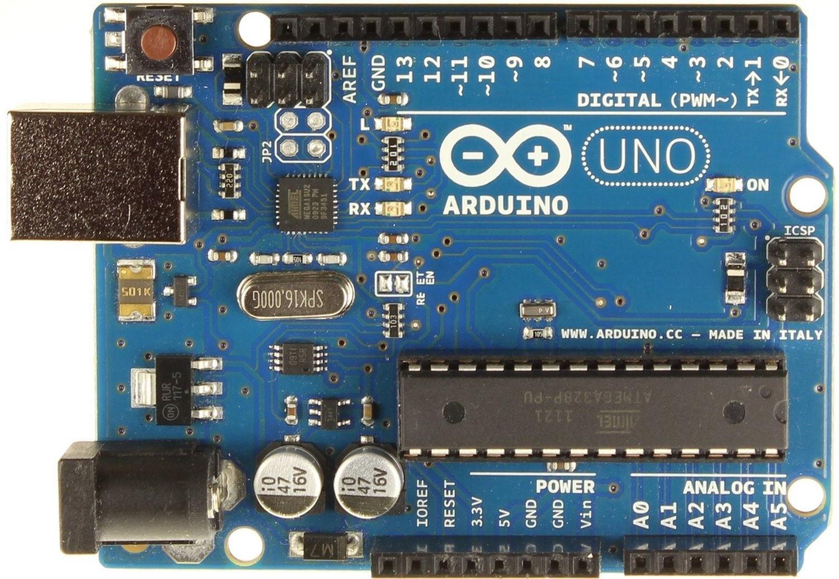

Figure3.1Arduino UNO

**Arduino** Uno is a microcontroller board based on the ATmega328P (datasheet). It has 14 digital input/output pins (of which 6 can be used as PWM outputs), 6 analog inputs, a 16 MHz quartz crystal, a USB connection, a power jack, an ICSP header and a reset button.

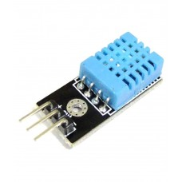

Figure 3.2 DHT11 temperature & humidity sensor

This DHT11 Temperature and Humidity Sensor features a calibrated digital signal output with the temperature and humidity sensor capability. It is integrated with a high-performance 8-bit microcontroller. Its technology ensures the high reliability and excellent long-term stability.  This sensor includes a resistive element and a sensor for wet NTC temperature measuring devices. It has excellent quality, fast response, anti-interference ability and high performance.

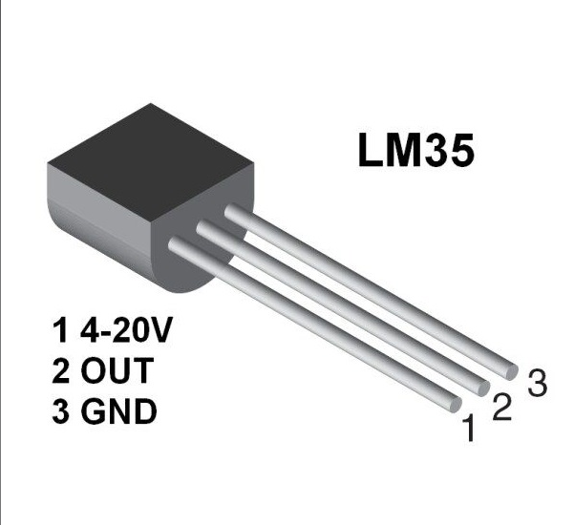

Figure 3.3 LM35 Temperature sensor

LM35 is a temperature measuring device having an analog output voltage proportional to the temperature. It provides output voltage in Centigrade (Celsius). It does not require any external calibration circuitry. The sensitivity of LM35 is 10 mV/degree Celsius. As temperature increases, output voltage also increases.

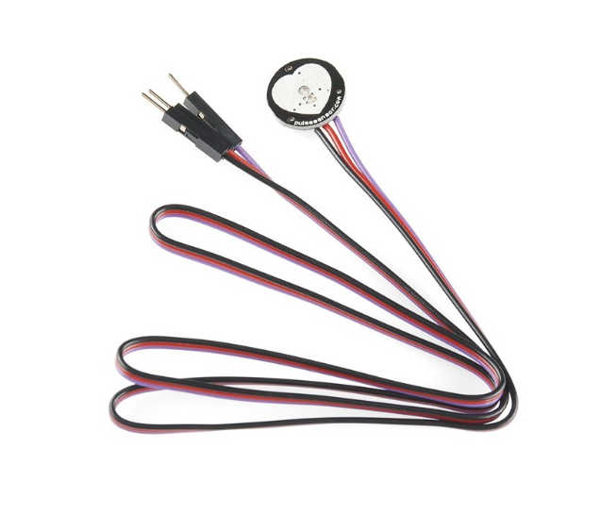

Figure 3.4 Pulse heart rate sensor

Pulse Sensor Amped is a plug-and-play heart-rate sensor for Arduino and Arduino compatibles. It can be used by students, artists, athletes, makers, and game & mobile developers who want to easily incorporate live heart-rate data into their projects. Pulse Sensor adds amplification and noise cancellation circuitry to the hardware. It's noticeably faster and easier to get reliable pulse readings. Pulse Sensor Amped works with either a 3V or 5V Arduino.

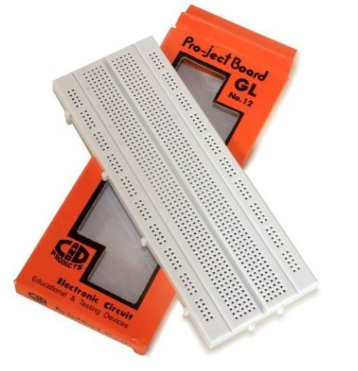

Figure 3.5 Breadboard

A **breadboard** is a solderless device for temporary prototype with electronics and test circuit designs. Most electronic components in electronic circuits can be interconnected by inserting their leads or terminals into the holes and then making connections through wires where appropriate.

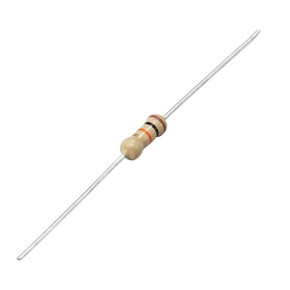

Figure 3.6 10k ohm resistor

A resistor is a passive two-terminal electrical component that implements electrical resistance as a circuit element. In electronic circuits, resistors are used to reduce current flow, adjust signal levels, to divide voltages, bias active elements, and terminate transmission lines, among other uses.

**3.4 Scheduling (Gantt chart)**

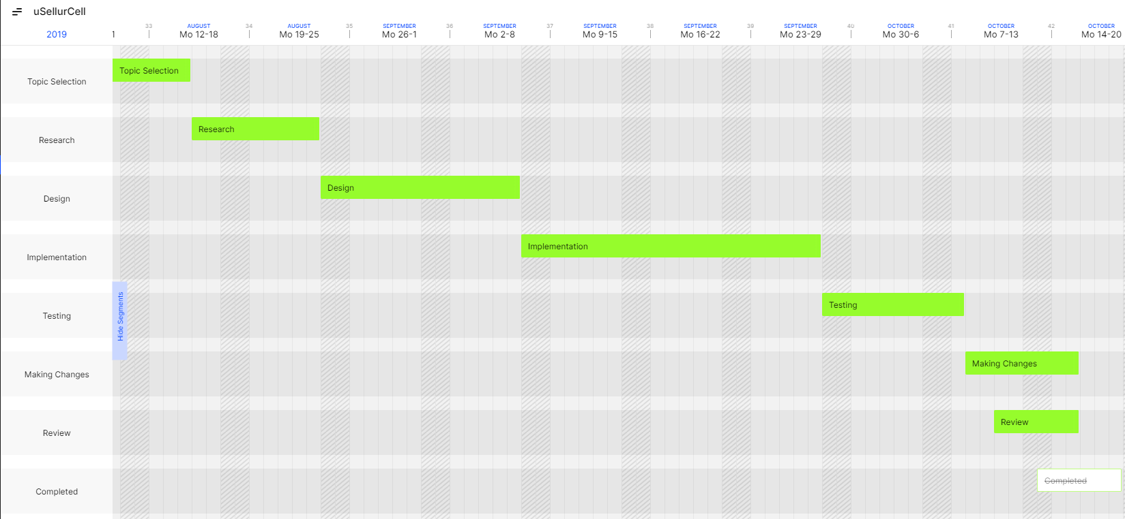

Figure 3.7 Gantt chart

**3.5 Understanding**

In this after understanding the topic the project feasibility was analysed by performing different types of feasibility studies and by also planning the project tools, their project schedule, timeline charts, etc. Feasibility study will help in better understanding the various feasibilities associated with the project and helping to make the correct decisions and completing the project within the schedule, budget, etc.

The tools were specifically identified in this chapter stating which technology can be feasible and how conveniently the project can be completed. This helps to understand the technology and tools that can be used for the project. The Gantt chart helps us to track the project and see the schedule of the project and to see if the project is on the right track and on schedule and not behind the deadline

**Chapter 4**

**Design Requirements**

**4.1 Block Diagram**

Figure 4.1 Block Diagram

Pulse Sensor

Humidity Sensor

Temperature Sensor

Serial Monitor

Bluetooth

Arduino UNO

**4.2 GUI (screenshots)**

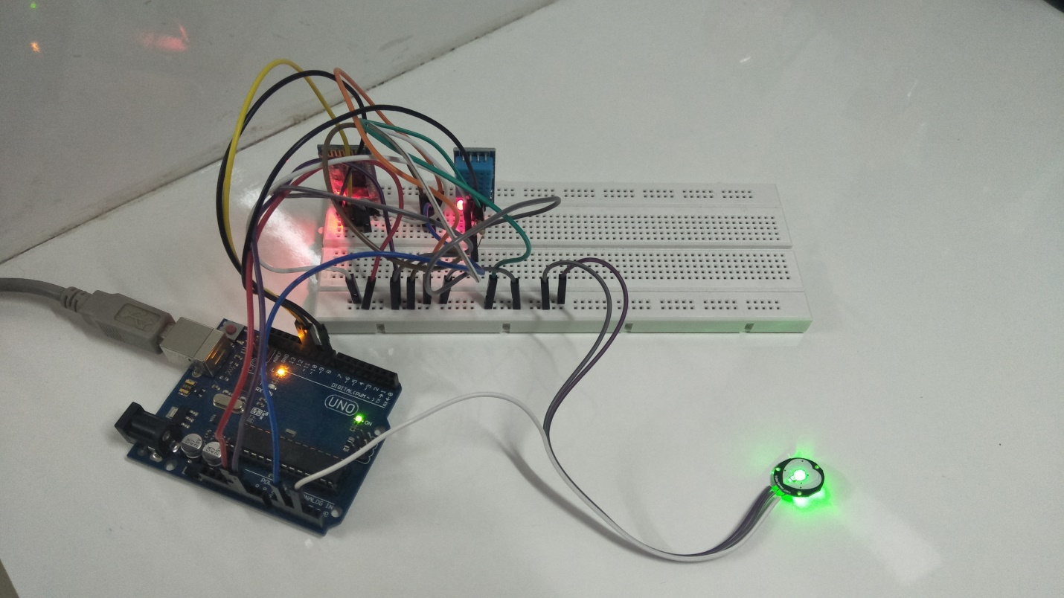

Figure 4.2 Final running of project

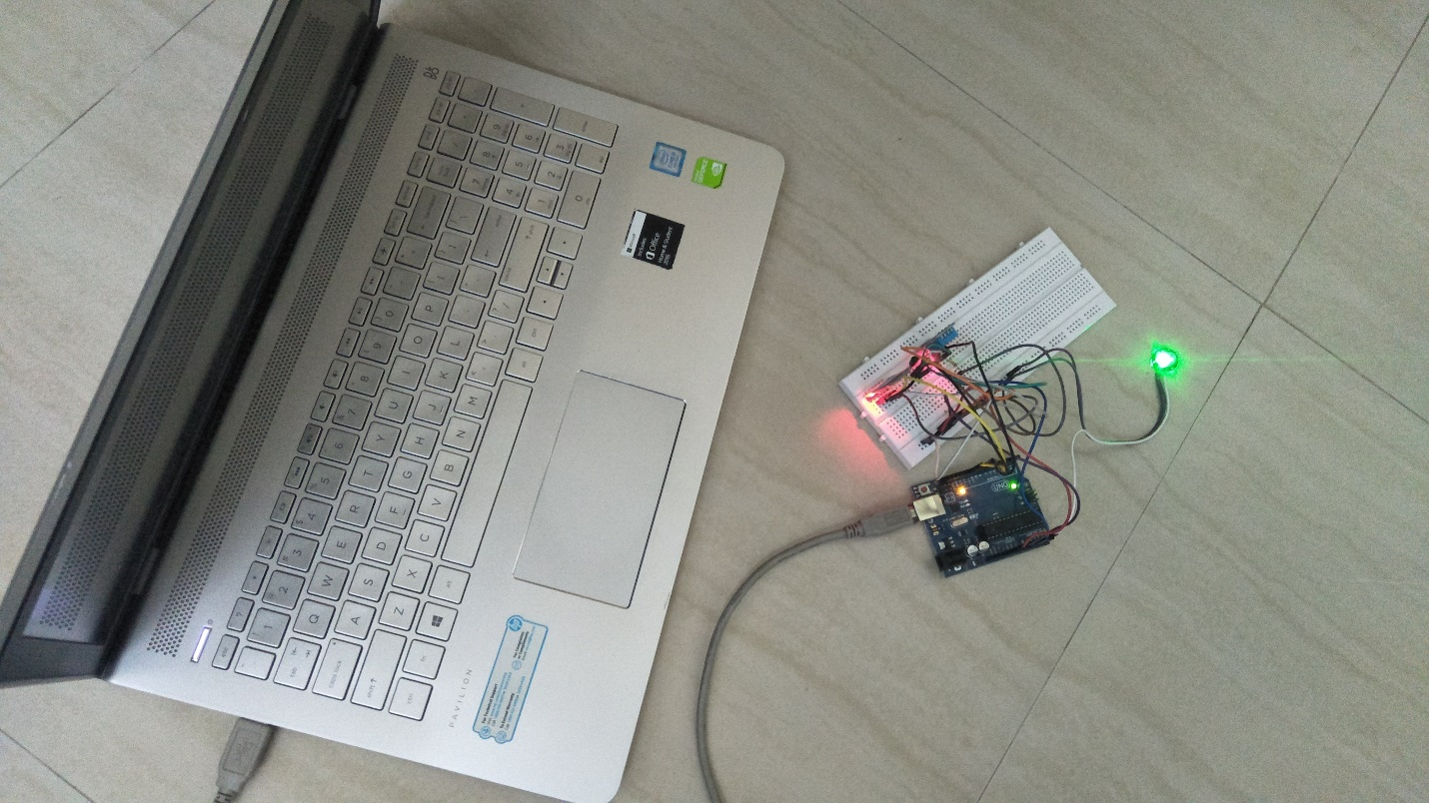

**Chapter 5**

Results & Discussion

**5.1 Results**

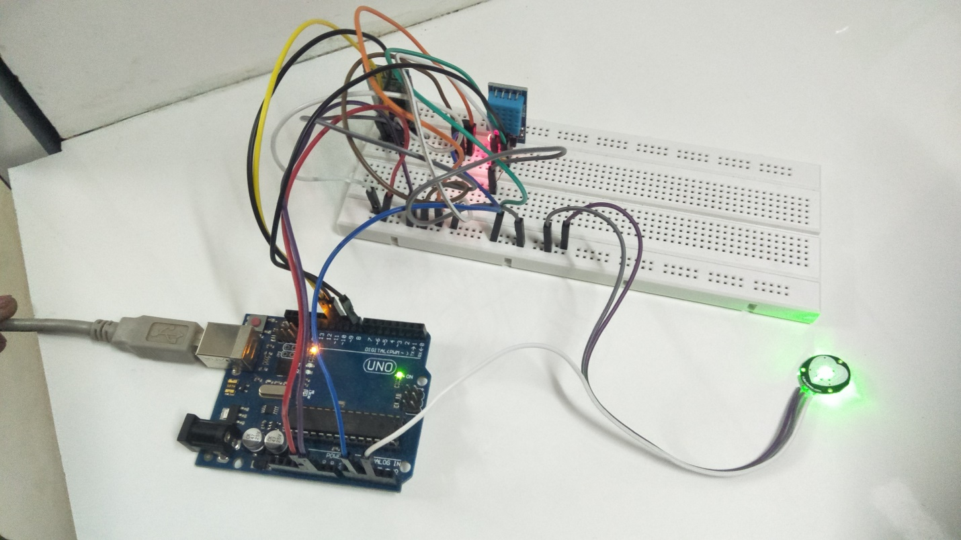

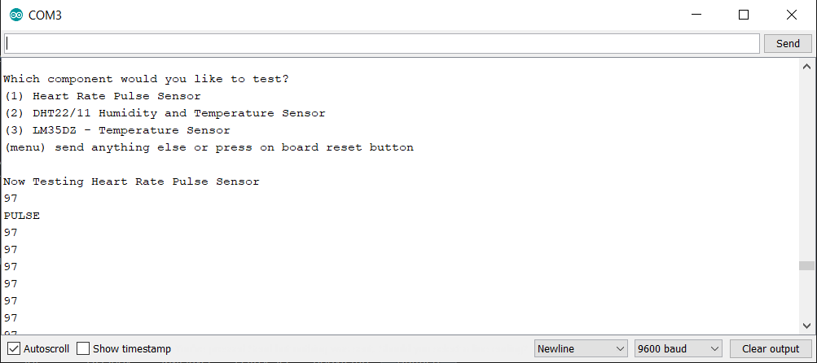

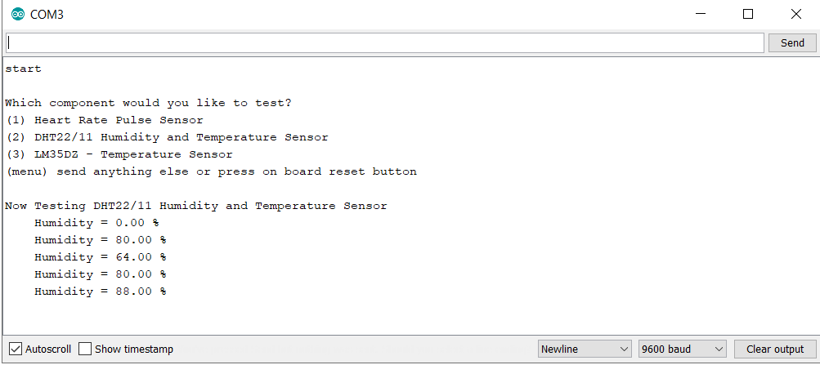

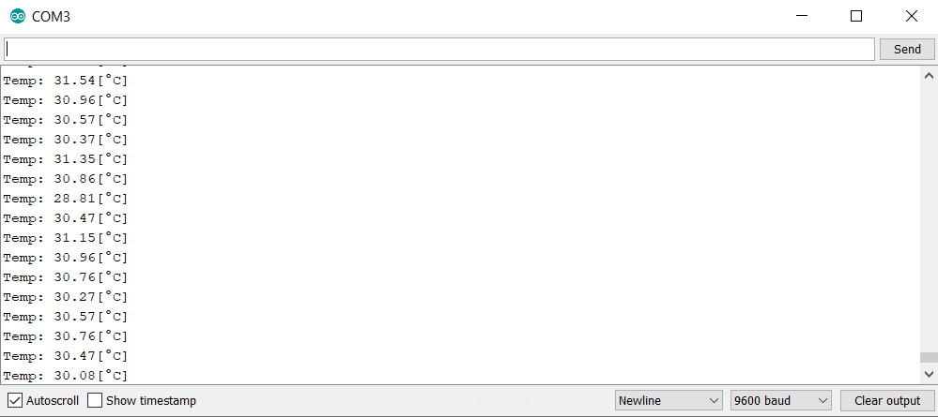

**Phase 1 Analysis**

Creating the synopsis, literature survey and feasibility study for proposed solution which will act as an input to the design phase.

**Phase 2 Planning:**

Proposing Statement of work, scope definition and scope boundary for planning the prototype from the problem definition to decide what needs to be done and what not to be done.

**Phase 3 Designing:**

Proposing design, architecture for the prototype.

**Phase 1 Implementation:**

Implementation of the Arduino model with the help code running itin the Arduino IDE environment.

**Phase 2 Testing:**

Testing was done by checking the results of different sensors used with the result that came when used dedicated tools for respective sensing. The testing of the model was a success are mentioned in the above figures.

**5.2 Improvements in Research Gaps (Findings)**

Every project has some gaps in it. No project is 100% efficient. There are some gaps in this project too. They are as follows:

1.As this system is currently not Bluetooth enabled, the sensor data is not visible onto mobile phones of the user. However, when serial monitor is used, the sensor data gets displayed. The output can be sent to mobile phones by using GSM module or Bluetooth module for further analysis.

2.More parameters (like blood pressure) can be added to the device.

3.Sound can be added to the device so that the device makes a sound each time a pulse is received and alarm is started for abnormal health condition.

4. In addition to the system can also provide more than one numbers so that more than one user can receive emergency message.

5. According to availability of sensors or development in biomedical trend more parameter can be sense and monitor which will drastically improve the efficiency of the wireless monitoring system in biomedical field.

**Chapter 6**

**Conclusion**

**6.1 Future Scope**

* Serial output can be incorporated into the device so that the heart rates can be sent to a Personal Computer (PC) for further online or offline analysis.
* Monitoring device that could be used to detect the heart beat anomalies of physically challenged Individuals without hands.
* It could be integrated with mobile technology for e-health cloud transmission to health care providers.
* Warning for abnormalities of health condition can be displayed.
* Sound can be added to the device so that the device makes a sound each time a pulse is received and alarm is started for abnormal health condition.

**6.2 Conclusion**

The compact sensors with IoT will make a huge impact on every patient’s life, that even though they are away from home and physician, this helps them to reduce the fear of danger. The sensory data can be acquired in home or work environments.

This is an important [sensor based project](https://www.projectsof8051.com/sensor-based-projects/) which has the latest technology implemented in it. The compact sensors with IoT will make a huge impact on every patient’s life, that even though they are away from home and physician, this helps them to reduce the fear of danger. The sensory data can be acquired in home or work environments.

IOT Healthcare is the most demanding field in the medical area. This project is for, elderly person in our home. Also, for the senior citizen living alone or living with 1 or 2 members. This project really proves helpful when family members need to go out for some emergency work.

Disable patients can use this project. Disable patients who find it really difficult to go to doctors on daily basis or for those patients who need continuous monitoring from the doctor.

**References**

1.<https://www.researchgate.net/publication/317117507_Heartbeat_and_Temperature_Monitoring_System_for_Remote_Patients_using_Arduino>

2.Manisha Shelar, Jaykaran Singh, Mukesh Tiwari, “Wireless Patient Health Monitoring System”, International Journal of Computer Applications

3.<https://medium.com/heartbeat-and-body-temperature-monitoring-using-arduino>

4.Rajalakhshmi.S S.Nikilla, “Real Time Health Monitoring System using Arduino”, South Asian Journal of Engineering and Technology Vol.2, No.18 (2016) 52–60 ISSN No: 2454-9614

5.C. K. Das, M. W. Alam and M. I. Hoque, “A Wireless Heartbeat and Temperature Monitoring.